Revisi Praktikum Manajemen Basis Data

Sandyatama Fransisna Nugraha

5025211196

**DDL and DML**

CREATE TABLE SINGER(

    SINGERID VARCHAR(5) NOT NULL PRIMARY KEY,

    SINGERNAME VARCHAR(50) NOT NULL

)

CREATE TABLE RECEIPT(

    RECEIPTNO VARCHAR(10) NOT NULL PRIMARY KEY,

    COSTUMERNAME VARCHAR(50) NOT NULL,

    RECEIPTDATE DATE NOT NULL

)

CREATE TABLE ALBUM(

    SINGERID VARCHAR(5) NOT NULL,

    ALBUMNO VARCHAR(5) NOT NULL PRIMARY KEY,

    ALBUMNAME VARCHAR(50) NOT NULL,

    RELEASEYEAR INTEGER NOT NULL,

    PRICE DECIMAL(10,2) NOT NULL,

    FOREIGN KEY(SINGERID) REFERENCES SINGER(SINGERID)

)

CREATE TABLE DETAILITEM(

    DETAILID VARCHAR(10) NOT NULL PRIMARY KEY,

    ALBUMNO VARCHAR(5) NOT NULL,

    RECEIPTNO VARCHAR(10) NOT NULL,

    AMOUNT INTEGER NOT NULL,

    TOTALPRICE DECIMAL(10,2) NOT NULL,

    FOREIGN KEY(ALBUMNO) REFERENCES ALBUM(ALBUMNO),

    FOREIGN KEY(RECEIPTNO) REFERENCES RECEIPT(RECEIPTNO)

)

INSERT INTO SINGER VALUES

('B01','ARIANA GRANDE'),

('I01','KAHITNA'),

('K01','BTOB')

INSERT INTO RECEIPT VALUES

('R0001','NATASHA MEIDYANI','2022-12-01'),

('R0002','HENDY AZMI','2022-12-02'),

('R0003','ATIKA FARAHDINA','2022-12-07')

INSERT INTO ALBUM VALUES

('B01','A01','THANK U,NEXT',2019,576000.00),

('B01','A02','POSITIONS',2020,615000.00),

('I01','A03','THE SIGNATURE COLLECTION',2020,460000.00),

('K01','A04','4U OUTSIDE',2021,535400.00),

('K01','A05','BE TOGETHER',2022,340000.00)

INSERT INTO DETAILITEM VALUES

('D0001','A01','R0001',4,2304000.00),

('D0002','A02','R0001',2,1230000.00),

('D0003','A05','R0001',5,1700000.00),

('D0004','A03','R0002',2,920000.00),

('D0005','A03','R0003',8,3680000.00)

1. Tambahkan dua kolom dengan nama : TAX dan NETPRICE pada tabel DETAILITEM dan lakukan penambahan data di kedua kolom tersebut dengan ketentuan sebagai berikut: a. Kolom TAX = 11% x TOTALPRICE apabila TOTALPRICE >= 1000000.00 dan 0.00 apabila TOTALPRICE < 1000000.00 b. Kolom NETPRICE = TOTALPRICE + TAX

ALTER TABLE DETAILITEM

ADD COLUMN "tax" DECIMAL(15,2)

ADD COLUMN "netprice" DECIMAL(15,2)

UPDATE DETAILITEM

SET TAX = CASE

           WHEN TOTALPRICE >= 1000000.00 THEN 0.11 * TOTALPRICE

           ELSE 0.00

         END,

    NETPRICE = TOTALPRICE + TAX;

Screenshot

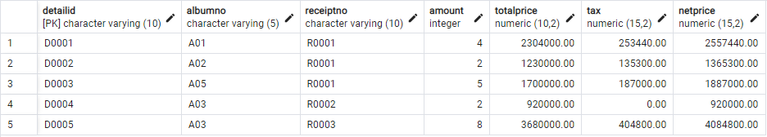

1. Tampilkan CUSTOMERNAME, RECEIPTNO, dan ALBUMNAME yang membeli album yang dirilis pada tahun 2020 - 2022!

Result

SELECT R.COSTUMERNAME,R.RECEIPTNO,A.ALBUMNAME

FROM RECEIPT R

INNER JOIN  DETAILITEM D ON R.RECEIPTNO = D.RECEIPTNO

INNER JOIN ALBUM A ON A.ALBUMNO = D.ALBUMNO

INNER JOIN SINGER S ON S.SINGERID = A.SINGERID

WHERE a.RELEASEYEAR BETWEEN 2020 AND 2022;

Screenshot

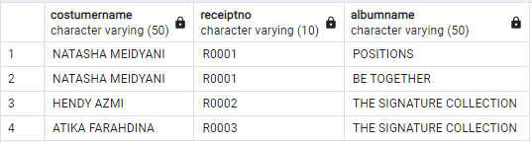

1. Tampilkan CUSTOMERNAME, RECEIPTDATE and rata-rata NETPRICE untuk masing-masing customer yang memiliki RECEIPTDATE kurang dari tanggal 5 Desember 2022 (angka ratarata dibuat dua angka di belakang koma)!

Result

SELECT R.COSTUMERNAME,R.RECEIPTDATE,ROUND(AVG(D.TOTALPRICE/D.AMOUNT), 2) AS NETPRICE

FROM RECEIPT R

INNER JOIN  DETAILITEM D ON R.RECEIPTNO = D.RECEIPTNO

WHERE R.RECEIPTDATE < '2022-12-05'

GROUP BY R.COSTUMERNAME,R.RECEIPTDATE;

Screenshot

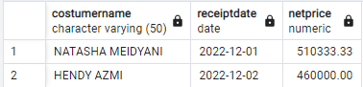

1. Tampilkan ALBUMNAME dan SINGERNAME dari album yang jumlah total terjualnya lebih dari 4 buah!

Result

SELECT A.ALBUMNAME, S.SINGERNAME

FROM ALBUM A

INNER JOIN SINGER S ON  A.SINGERID = S.SINGERID

INNER JOIN DETAILITEM D ON A.ALBUMNO = D.ALBUMNO

GROUP BY A.ALBUMNO, A.ALBUMNAME, S.SINGERNAME

HAVING SUM(D.AMOUNT) > 4;

Screenshot

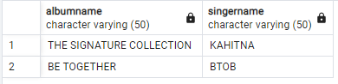

1. Tampilkan NOALBUM, ALBUMNAME, SINGERNAME, dan total NETPRICE yang memiliki total NETPRICE dibawah rata-rata total NETPRICE tiap albumnya (album yang tidak terjual juga diperhitungkan dalam perhitungan rata-rata dan total NETPRICE ditampilkan dalam bentuk dua angka di belakang koma)!

Result

SELECT A.ALBUMNO, A.ALBUMNAME, S.SINGERNAME, ROUND(SUM(D.NETPRICE),2) AS TOTALNETPRICE

FROM ALBUM A

JOIN SINGER S ON S.SINGERID = A.SINGERID

NATURAL LEFT JOIN DETAILITEM D

GROUP BY A.ALBUMNO, A.ALBUMNAME, S.SINGERNAME

HAVING SUM(D.NETPRICE) <

    (SELECT AVG(NETPRICE)

     FROM DETAILITEM);

Screenshot

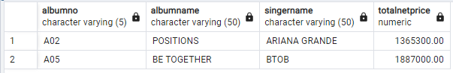

1. Tampilkan SINGERNAME, total AMOUNT dan total NETPRICE setiap penyanyi yang diurutkan mulai dari total NETPRICE tertingi hingga terendah (total NETPRICE ditampilkan dalam bentuk dua angka di belakang koma)!

Result

SELECT S.SINGERNAME,

       SUM(D.amount) AS TOTAL_AMOUNT,

       ROUND(SUM(D.NETPRICE), 2) AS TOTAL_NETPRICE

FROM SINGER S

INNER JOIN ALBUM A ON S.SINGERID = A.SINGERID

INNER JOIN DETAILITEM D ON D.ALBUMNO = A.ALBUMNO

GROUP BY S.SINGERNAME

ORDER BY TOTAL_NETPRICE DESC

Screenshot

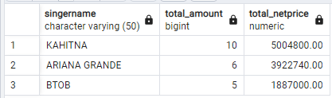

1. Tampilkan persentase total NETPRICE album “BE TOGETHER” terhadap total keseluruhan NETPRICE (hasil persentase dibulatkan dua angka di belakang koma)!

Result

SELECT ROUND(SUM(CASE WHEN ALBUMNAME = 'BE TOGETHER' THEN NETPRICE ELSE 0 END) * 100 / SUM(NETPRICE), 2) AS PERCENTAGE_NETPRICE

FROM SINGER S

INNER JOIN ALBUM A ON S.SINGERID = A.SINGERID

INNER JOIN DETAILITEM D ON D.ALBUMNO = A.ALBUMNO

Sreenshot

